Tuning Classification threshold

Classification threshold:
Suppose we have some predicted probability for positive class,to convert them into class labels,we need threshold
threshold = 0.5
For example:
Probability | Threshold | Prediction
0.91 | 0.50 | 1
0.62 | 0.50 | 1
0.47 | 0.50 | 0

Threshold = 0.5 for binary classificationis a natural default because
P(class 1) >= P(class 0).
But this doesn't mean it always best.

Why 0.5 is not always optimal?
The threshold should oftendepend on real world consequences of mistakes.
Consider Cancer screening.
There are two possible errors:
False positive → healthy patient predicted as sick.
False Negative → Sick patient predicted as healthy
These errors are not same equally serious. Missing a cancer patient can be worse than sending a healthy patient for an additional test.
Therefore, we intentionally lower the threshold from 0.50 → 0.30 To identify more potentially positive patients.

Threshold value change predictions:
Suppose probabilities are:
Actual : 1, 0, 1, 0, 1, 0
Probability : 0.90, 0.72, 0.61, 0.48, 0.41, 0.10
At threshold 0.50 :
Predictions : 1, 1, 1, 0, 0, 0
At threshold 0.30 :
Predictions : 1, 1, 1, 1, 1, 0
Changing the threshold doesn't retrain themodel. It simply changes how predicted probabilities are converted into final decisions.

Threshold & Confusion Matrix:
Threshold change/tuning changes all four quantities of Confusion matrix.
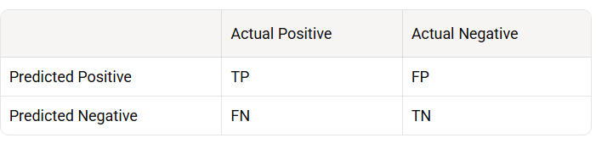
When we lower the threshold:
Suppose : Threshold : 0.50 → 0.30
More cases are classified as positive.
Usually TP↑, FP↑, FN↓, TN↓
Therefore usually recall↑, Precision↓
This is the fundamental precision-recall tradeoff.
When we Raise the threshold
from 0.5 → 0.8.
The model requires more confidence before predicting positive.
Usually : TP↓, FP↓, TN↑, FN↑
Therefore : Precision↑, recall↓

Precision:
It answers: of everything predicted positive, how many were actually positive?
Precision = $\frac{TP}{TP +FP}$ ​
Suppose : TP = 80 , FP = 20
P = 100/80​ = 0.80
80% of cases flagged by model were actually positive.

Recall:
It answers: of all actual positives cases, how many did we successfully detect?
Recall = $\frac{TP}{TP+FN}$
​The model detect 80% of all positive cases.

Precision Recall Trade off
Suppose : Threshold = 0.20
Result : TP↑=95, FP↑=70, FN↓=5, TN↓=830
Recall : $\frac{95}{95+5}$ ​= 0.95↑
Precision : $\frac{95}{95+70}$​= 0.57↓
It means: We detected almost all positive cases but generated many false alarms.
Suppose threshold : 0.8
Result: TP↓=55, FP↓=5, FN↑=45, TN↑=895
Precision : $\frac{55}{55+5}$ ​= 0.91↑
Recall :$\frac{55}{ 55+45}$​= 0.55↓
It means, positive predictions are highly trustworthy, but the model misses many true positives.
Generally:
Threshold ↑ → Precision↑, Recall↓
Threshold ↓ → Precision↓, Recall↑

Note:
When precision & recall, are not identified which one is important, then we find f1-score but f1-score is not automatically the best business threshold. It treats things mathematically rather than financially.
Therefore threshold is selected by:
- Business cost
- Business constraints
- Risk tolerance
- Operational capacity.

Threshold Selection Based on Business Cost
Suppose:
False positive cost = $50
False negative cost = $1000
For every threshold calculate
TotalCost = FP∗Cost_{FP}​ + FN∗Cost_{FN}
​Then choose threshold with lowest total cost

Selecting threshold on Minimum Recall
Sometimes business doesn't give a dollar cost. Instead it gives a requirement
For example:
We must detect at least 90% of recall.
Same for precision.

Threshold based on Operational Capacity
